s | Restaurant Management  System  Technical Design Document  1.0
 | Prepared By / Last Updated By | Reviewed By | Approved By
Name | Shrey Agarwal, Deepankar Ratra, Punit Jain | Mr. Abhinandan | Mrs. Shilpa Mahajan
Role | Team Members | Mentor | Academy Head
Signature
Date

Table of Contents

1.0 Introduction 3
1.1 Purpose of this document 3
1.2 Scope 3
1.3 Intended Audience 3
1.4 Definition & Acronyms 3
2.0 Conventions and Standards Followed 4
3.0 Assumptions, Dependencies and Risks 4
3.1 Assumptions: 4
3.2 Dependencies: 4
4.0 Schematic Diagram 4
5.0 Use Case Realization 5
5.1.1 User Registration 5
a. Functional Requirement 6
b. UI Validations 6
c. UI Controls 7
d. UI Methods Definition 8
e. UI Design 9
6.0 Database Design 10
6.1 Data Model 10
6.2 Tables Structure 10
7.0 Change Log 13

Introduction

Purpose of this document
The purpose of the detail design document is to define the detailed design for all the components of Restaurant Management System that are specified in the Business Requirement/Use case document. All the low level components, interfaces and integrations are detailed out in this document.

Scope
This sub-section shall state the scope of this detailed design document
• Create and maintain admin information.
• Create and maintain inventory information.
• Create and maintain staff information.

Intended Audience
The intended audience for this document are
- Developers, testers, other associates in the project
- Technical lead, Scrum Master
- Product Owner

Assumptions, Dependencies and Risks

Assumptions:
- Once the application is built the Bill Payment System will manually load the admin list into the system.
- Any changes to the design mentioned in the BRD would be taken as a Change Request

Dependencies:
- Availability of database design characteristics & access shall be defined by the admin.
- Resource availability throughout each of the sprint

Schematic Diagram
A schematic, or schematic diagram, is a representation of the elements of a system using abstract, graphic symbols rather than realistic pictures. It gives an overview of overall system
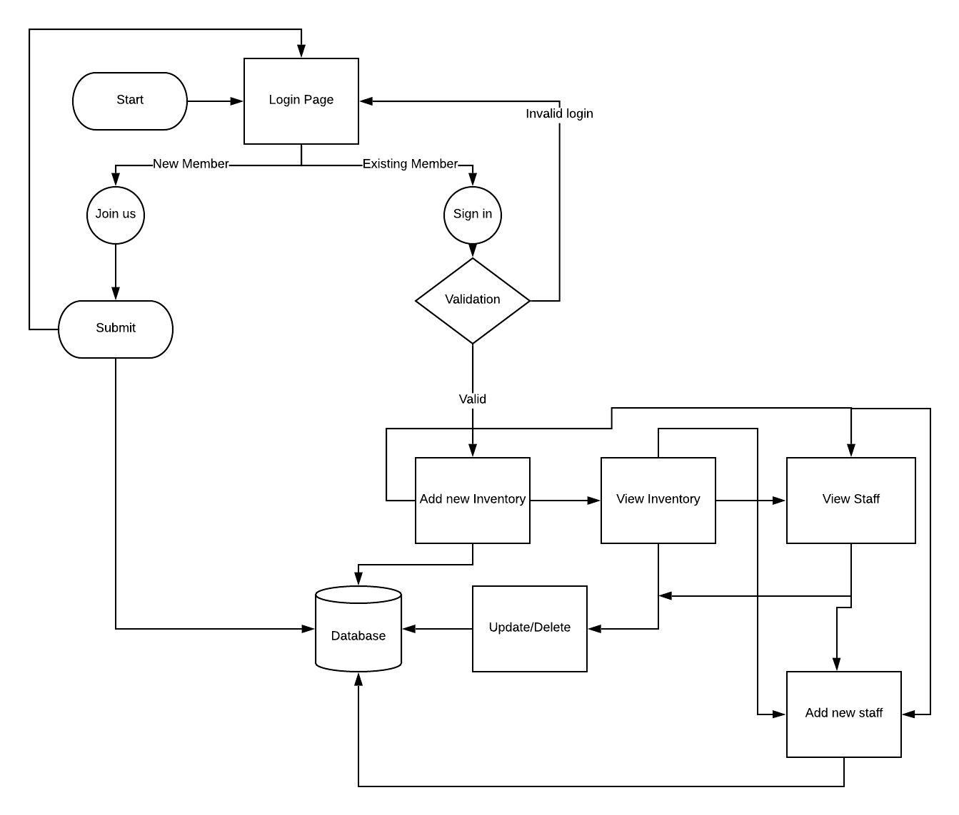
DFD for Restaurant Management System

Use Case Realization

Admin Registration

Functional Requirement
. Login Page checks the authentication of the admin and directs the admin to the respective page. Admin will be provided with links to view Inventory list, add staff details and view, update, delete the staff details.

UI Validations
- User Id and Password fields are mandatory.
- Invalid User Id and / or password should not allow the admin to get into the system

UI Controls
# | UI Component | Type | Name | Details
1 | User id | Text Field | username | To enter user id
2 | Password | Password | password | To enter password

UI Methods Definition
Method Name | Parameter | Details
Sign_in_Button_Click | object sender, EventArgs e | Allows the admin to login into the portal.
Join_us_Button_Click | object sender, EventArgs e | Allows the admin to insert the admin details.

UI Design
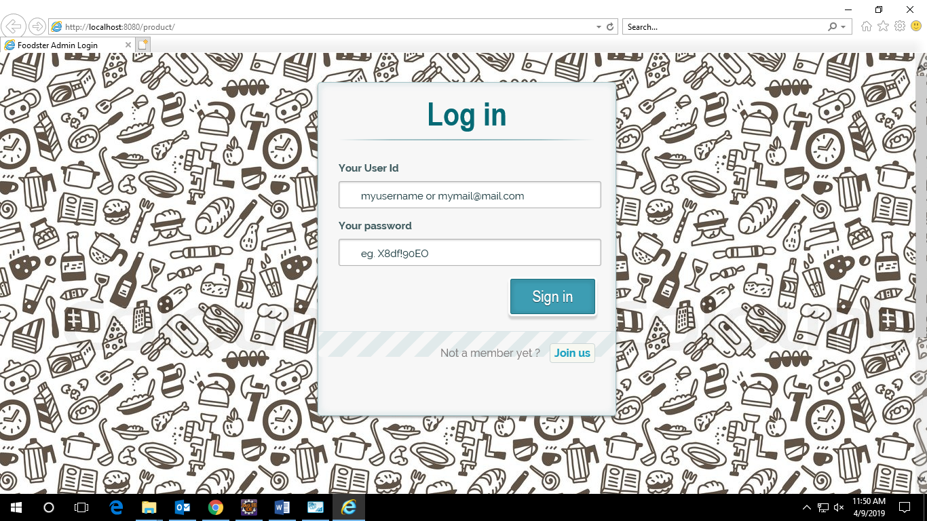

Database Design

Data Model

The following is a schematic view of the database design
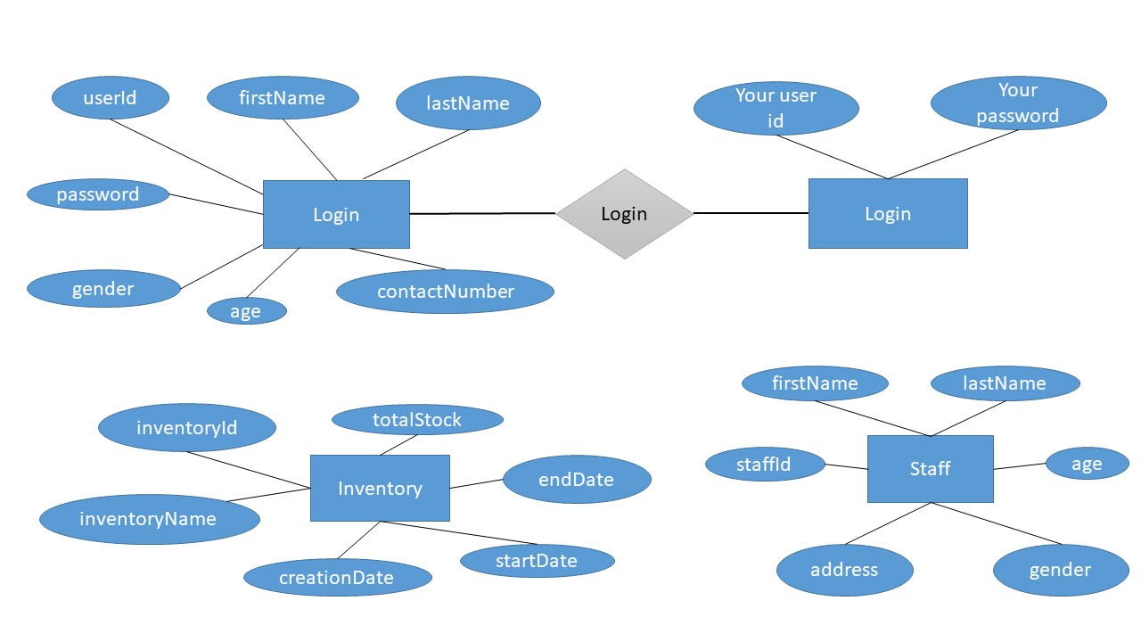

Tables Structure
Login :
Field Name | Field Type | Data Type | Mandatory | Possible values
userId | Varchar(255) | Alphabetic | YES
age | Int(11) | Numerical | YES
contactNumber | Int(11) | Numerical | YES
firstName | Varchar(255) | Alphabetic | YES
gender | Varchar(255) | Alphabetic | YES | Male, Female
lastName | Varchar(255) | Alphabetic | YES
password | Varchar(255) | Alphabetic | YES

Inventory :
Field Name | Field Type | Data Type | Mandatory | Possible values
inventoryId | Varchar(255) | Numeric | YES
creationDate | Local Date | Date | YES
endDate | Local Date | Date | YES
inventoryName | Varchar(255) | Alphabetic | YES
startDate | Local Date | Date | YES
totalStock | Int(11) | Numeric | YES

Staff:
Field Name | Field Type | Data Type | Mandatory | Possible values
staffId | Varchar(255) | Alphanumeric | YES
address | Varchar(255) | Alphanumeric | YES
age | Int(11) | Numeric | YES
firstName | Varchar(255) | Alphabetic | YES
gender | Varchar(255) | Alphabetic | YES | Male, Female
lastName | Varchar(255) | Alphabetic | YES

Change Log
Please note that this table needs to be maintained even if a Configuration Management tool is used.
Version Number | Changes made
V1.0 | <First version>
V1.1 | <If the change details are not explicitly documented in the table below, reference should be provided here>
V1.1 | Page no | Changed by | Effective date | Changes effected
V1.2 | <If the change details are not explicitly documented in the table below, reference should be provided here>
V1.2 | Page no | Changed by | Effective date | Changes effected

